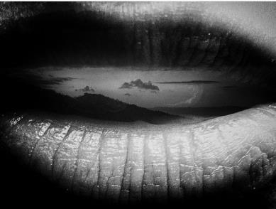
Photo courtesy of Leo Pinter ©

An African network of MHH academics, artists, healers and activists.

••••••••

Web: https://medicalandhealthhumanities.africa

FB:www.facebook.com/groups/2437260669830446/

The Medical Humanities program at WiSER, in conjunction with the Medical and Health Humanities Africa network and the Primary Health Care Directorate at UCT, would like to announce a forthcoming virtual symposium.

BREATH: INSPIRE/EXPIRE

19th October to 13 November 2020

Discussions on the topic of breath have become pertinent with the coronavirus affecting how we think about breath and breathing; lungs and livelihoods; and as we bear witness to the asphyxiation of the planet and people at the hands of the powerful and privileged.

The symposium brings together academics, artists, activists and practitioners who work on the intersections of social sciences, humanities, health sciences, arts and activism to creatively think about the many ways that breath and breathing feature in our everyday lives. We invite you to join us to collectively explore themes around breath - the physical processes to inhale, or inspire - and exhale, or expire - as well as metaphorical or conceptual extensions of what it means to inspire and expire.

The program features diverse presentation formats including academic panels, poetry, photography film, and music. We invite you to view our virtual gallery where we will be posting creative work which can be accessed over the period of the symposium. We will also have academic panels every week, virtual workshops, and keynote speakers.

Please join us for these events and our two keynotes:

Dr Ela Manga, Integrative Medical Practitioner, 30 October 2020
Prof. Jane Macnaughton, Director, Institute for Medical Humanities, Durham, 12 November 2020

To receive weekly updates during the symposium subscribe to our newsletter at
www.medicalandhealthhumanities.africa, join the MHHA Facebook Group at www.facebook.com/groups/2437260669830446, or follow us on Twitter - MHHA at @AndMhha and on Instagram.

