Avian Humanities Talk
Ryan Bishop
“Abstracting Flight: Datafication and Divination, or Birds and/as Media Technologies”
“No foreign sky protected me. No stranger’s wing protected my face.” -- William Kentridge “You Whom I Could Not Save” (2023)
“At the brink of dawn…” the opening and oft-used refrain in Amié Césaire “Notebook of a Return to My Native Land” (1939)
As we turn the crepuscular corner of day to night and night to day, we migrate between our native lands of consciousness and unconsciousness, much as Césaire did, ushered in with an aubade of bird song. If the dawn song, the aubade, as a foundational trope in Western poetry and music was populated by clandestine lovers wracked by bittersweet parting in the early light, then the background score of this romantic angst emanated from tree branches. Bird song, though, is often an aggressive staking out of territory regularly and historically misinterpreted as twittering beauty by human ears. Bird hermeneutics ground much of human interaction with our winged kin. Whether extractive or yearning-filled in our interpretations, we are often horribly awry…yet we persist, insistently drawn by their movement, flight, song, attractive alterity, and their time-marking of liminality.
At the brink of dawn, so we begin.

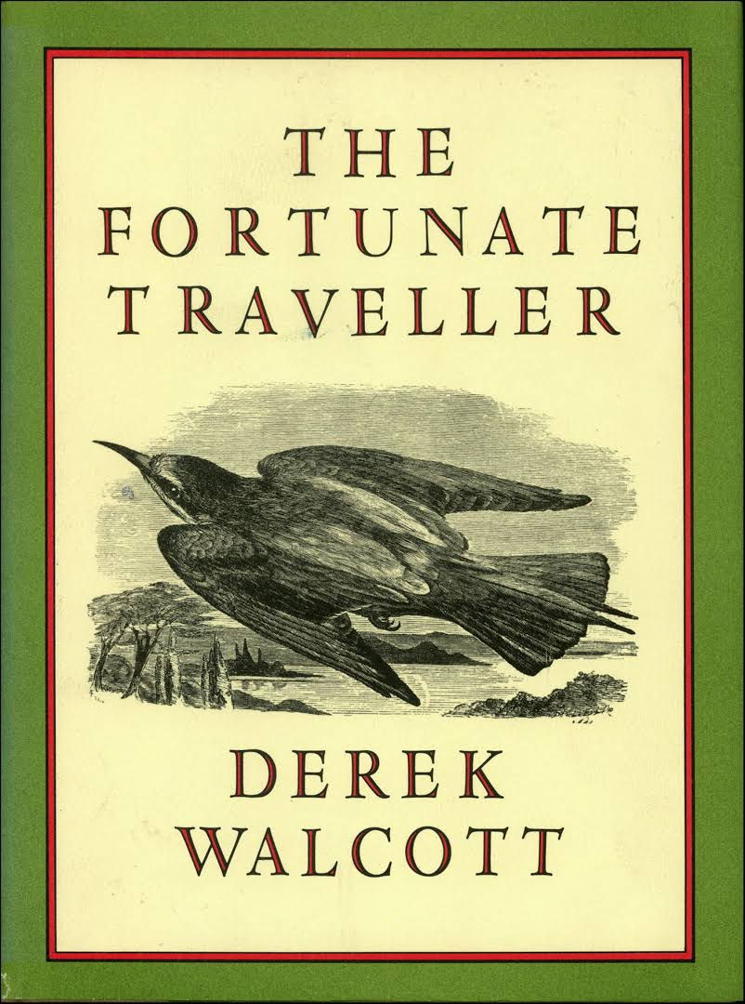
Derek Walcott’s 1980 collection of poetry entitled The Fortunate Traveller is divided into three sections: “North-South-North” an ABA structure of slant rhymes framing geographical dislocation and flight physical, psychological and moral. The final two poems chart different visions of flight: the penultimate one witnessing a Malthusian nightmare of sustained probabilistic figures in international aid and agrarian assistance resulting in corruption and enforced famine. It is followed by the final poem in the book that immerses us in a necromantic dream of birds as mediums trafficking between the heavens and the earth. In these we find a shift from our own current probabilistic universe and the geopolitical systems that have wrought many of our current crises to a hope for a future crafted out of care, of charity, and love predicated on a phantasy of the past, with birds playing an important role as the medium of brief relief.
The eponymous poem, the dire penultimate one, riffs on the 16th century picaresque novel The Unfortunate Traveller by Thomas Nashe, the title of which invokes the horrors and hypocrisies the protagonist witnesses, participates in and financially benefits from on his travels through Europe as a soldier and a Duke’s page. Walcott’s first-person persona enacts a similar dark night of the soul altering an international body’s statistics on grain sales and distribution for individual gain under the auspices of corrupt regimes in Africa. Scraping profits from disaster relief generates more and targeted mass starvation. He writes: “Famine sighs like a scythe/ across the field of statistics and the desert/ is a moving mouth. In the hold of this earth/ 10,000,000 shoreless souls are drifting./ Somalia: 765,00, there skeletons will go under the tidal sand.” He invokes “the individual sorrow” “screwed down to an oval nest of antic numbers” that condense it to the “zero” of the globe found in the aerial view of the planet from space and a first-class airplane cabin.
The volume’s closing poem, one of Walcott’s most well-known works, is “The Season of Phantasmal Peace” with its opening lines: “Then all the nations of birds lifted together/ the huge net of the shadows of this earth/ in multitudinous dialects, twittering tongues/ stitching and crossing it.” The invocation of the salvation manifested by the nation of birds appears as a phantasmal light “that not the narrowest shadow dared to sever,” a moment between dusk and dark when the “seasonal passing” of “Love” is “made seasonless” out of “pity for the wingless ones” dwelling in endarkened hovels below. The Love stays for only a brief crepuscular moment, “between fury and peace,/ but, for such as our earth is now, it lasted long.”
Not only do the two poems chart movements from north to south and back again, they also invoke two different takes of flight, each embedded in the other. Further it traces a trajectory between a probabilistic universe emergent from the 19th century and dominant in the present and universes in which ornithomancy unsealed fate – birds serving as a medium between the gods and the wingless ones. In other words, the poems move from datafication to divination. With avian hermeneutics, in a very real sense, datafication results in divination and divination results from datafication. The epistemology of ornithomancy resides in datafication converted to interpretation: discrete miniature moments that unlock the future’s opacity.
These categories of human-avian interactions and interpretations take off from a short piece of writing by the artist Abelardo Gil-Fournier and theorist Jussi Parikka that unpacks Gil-Fournier’s artwork “Artificial Divination”. Implicit in their two categories is the third one outlined above: datafication and/as divination. Gil-Fournier and Parikka do not go in this direction and instead posit “natural computation,” which connects experimental computation and artistic work with human-animal interactions or interpretations that gesture toward potential expansions of more-than human computation. Gil-Fournier’s artwork, “Artificial Divination,” offers some examples of ornithomancy, including Cicero’s debunking of the same.
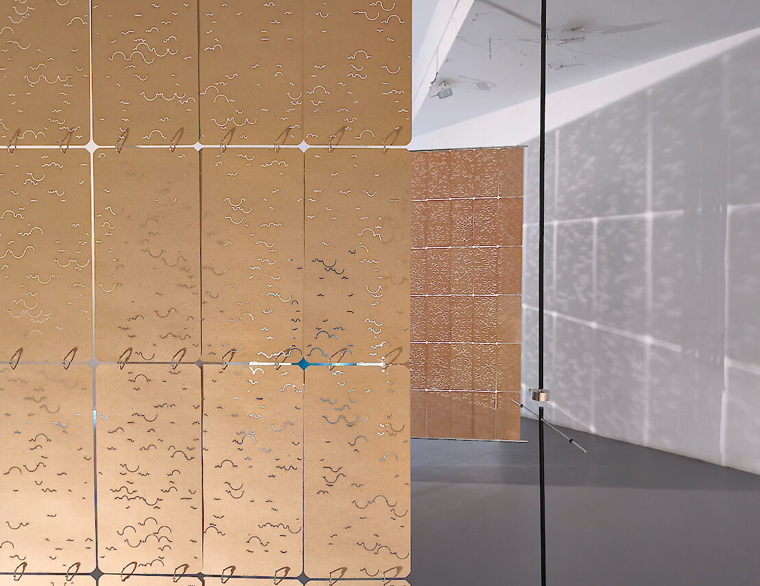

The works trace three examples, one from “Hittite divinations texts (14th-13th centuries BCE)” written on clay tablets in cuneiform script that describe explicit details of šwalni birds walking and flying and what their actions and movements portended for the observer. Bird oracles were key to Hittite cosmology. A second example included in the hanging panels comes from the sixth-century Sanskrit encyclopedia the Brihat Shamita that provides the if/then structure of decision-tree logics of computational software. In this case, if a crow turns its head in a specific way and opens it beak like so, then that spells bad news for your enemy’s leader.
The avian hermeneutics on display in both examples conflate specific data points and small discrete units into meaningful predictors of the future. A firm belief in such simplistic connections over the centuries is challenged in the third and final set of panels. The skeptical take from Marcus Tillus Cicero’s 44 BC work De Devinatione, in which he breaks the causal relationship between human interpretation of avian actions and futural events through examples that offer the fine art of sustained debunking.
The layout of Gil-Fournier’s panels that embody snippets of original texts and include a typography based on the EURING “bird ringing” system that helps scientists and others along the Eurasian-African flyway with material, information and data needed for collaborative research, data sharing and scientific conferences. Its simplified Roman alphabet allows data sharing across languages based on frequency of appearance clustered into groups called rings. Gil-Fournier embellishes the work’s EURING typography by including a graphic score of half-rings visually invoking mountains and valleys based on birdsong notational methods. His artwork is comprised of texts with data, translation, history of avian divination, graphic design and bird music.

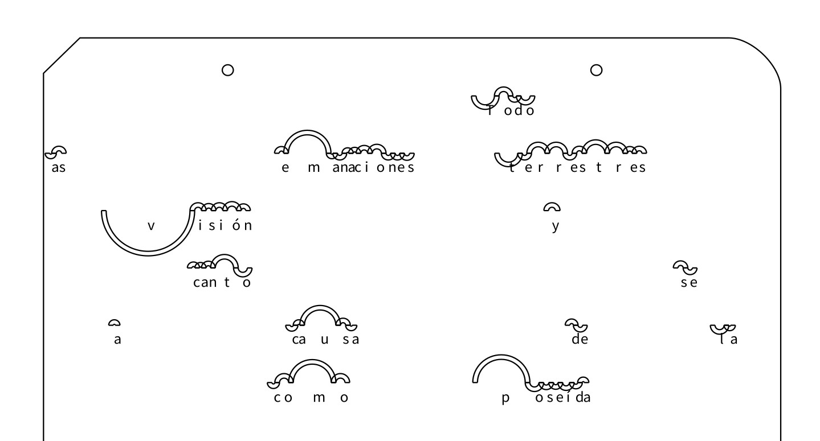

The third step of datafication as divination is implied in Gil-Fournier and Parikka’s short text though not explicitly stated or unfolded. This step, though, essentially exists at all stages of avian-human hermeneutics. The ancient Hittite and Sanskrit texts construct each small movement as a data point of portentous meaning for the future. The context of the interpretation of the text (for example, bird color or type, its movements in a particular setting, etc.) meant different things depending on the futural event to be gleaned, especially an answer to a pressing problem in which the outcome remained uncertain: e.g. the result of a forthcoming battle, a ruler’s demise, the end of a drought, the wisdom of an alliance between two parties, or the possibility of the reciprocation of romantic love. Fate might not exist in one’s hands, but it was discernible in the wings, beaks, claws, song and movements of another species.
Birds Enter the Picture: Digital Logics Predating Digital Technologies
“For the flight of birds for instance, I have been dreaming of some sort of photographic gun which would catch birds in an attitude, or better even in a succession of attitudes, displaying the successive phases of the movements of their wings.” -Étienne-Jules Marey, a portion of a letter to the editor of “La Nature” 28 December 1878 requesting an introduction to Eadweard Muybridge to gain better insight into chronophotography
“A bird in flight, any child knows, is easy to draw: two pencil or charcoal marks, move the marks along, change the angle of the two marks, the wing, and the bird will fly itself. This is both mimetic – it is rare not to see some bird traversing the highveld sky – but it is also a clock, marking out of time, pulling time into the film.” – William Kentridge A Natural History of the Studio (41)

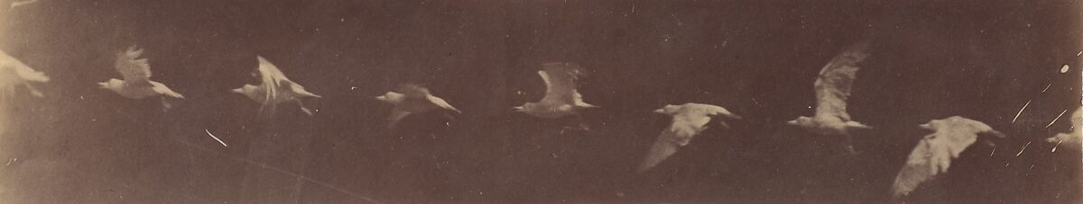
Marey sequence of individual photographic images
Sequenced photographs fascinated Etienne-Jules Marey just as much as the flight of birds and animal motion in general. Edwaerd Muybridge shared these fascinations and their relationship to the camera. Muybridge’s motions studies resulted eventually in the establishment of the earliest version of animated movement using photographic film, and therefore spoke to Marey’s imagination and experimentation. In a letter to Gaston Tissandier, editor of “La Nature,” Marey asked for help from Muybridge to develop his own scientific studies in animal motion studies. Marey had in mind the initial plans for a technological mechanism that would allow photographic capture of such motion, a mechanism largely motivated by bird flight and the human hunting of them during the same. Muybridge affixed his motion-studies to a series of static cameras positioned at different sites along a line of travel, as with his famous work of running horses for railroad baron Leland Stanford. In contrast, Marey dreamt of a single mobile camera model, potentially hand-held, that could track animal movement much as a hunter tracks its prey. The relationship between this camera, the later cinema camera of Lumiere Brothers, and the US Civil War invention of the gatling gun (precursor to the machine gun) is part of the technological innovations linking cinema and war (see Paul Virilio in War and Cinema: The Logics of Perception). It is also worth noting that the primary proponent of cybernetics, Norbert Wiener, mathematically computed ground based antiaircraft firing trajectories during WWII. The adjustments made in flight and firing tracking played a significant role in theorizing homeostasis in mechanical and biological systems operations.

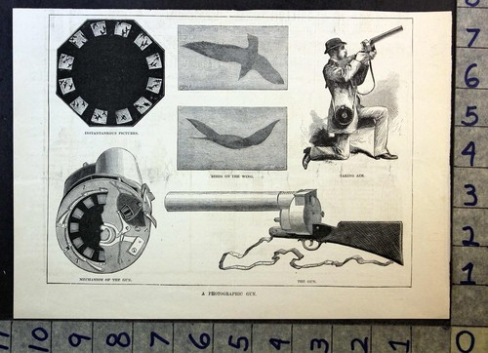
The insight both Muybridge and Marey leveraged was that to study movement faster than the human eye can process and see, one needs to slow it down (Bishop and Phillips XX). That is, one needs to take the dynamic process of motion and break the analogue process of continuity into its digital components that convert temporality into spatial storage. Time’s flow had been rendered material, malleable and durationally flexible: a complex dynamic system fractured into controllable units. From these units of infinitely repeatable units (as with alphanumeric writing), the flow and process of motion can be seen in its isolated parts and reconstructed as motion in a sequence of images or in a single image containing time-lapse composites. From these digital slices of time, datafication of the action can be constructed, modeled and studied.
Beyond the mechanism that could capture flight on film, Marey’s real interest resided in the mechanism of bird flight itself. Wherever Marey lived, he brought with him a menagerie and a lab bristling with recording instruments because these technologies unlocked for him the mysteries of biological existence in all animate creatures. The limitations and lacunae of human senses could be overridden, the physiologist posited, by technological prosthetics. Following numerous bird flight studies in France in the 1860s and 1870s, Marey sought to isolate and measure the motion of bird wings in flight. He thought this decontextualized movement allowed his studies to be empirical while also avoiding abstraction, which seems logically contradictory. Marey approached the bird less as whole being than as a flight mechanism to be mechanically measured and studied (Dagognet 111-122). His shift after the 1873 volume, Animal Mechanism, refined mathematical measurements of various physical forces at play in bird flight in the 1890 volume Le Vol des oiseaux (The Flight of Birds). His measurements drew not only on biological measurements of weight, force, resistance, and acceleration but also ballistics (placing his photography firmly in the lineage of motion studies we can classify as “ballistic aesthetics” that finds its quintessential form in the work of Harold Edgerton Marey’s lab assistant, Victor Tatin, argued in an article that it was not the bird that should be copied, measured and studied but its flight: action removed from the ontological entity performing that act. Both Marey and his lab assistant moved from “ornithological copy to a purely-mathematical solution” for cracking the avian flight code (Dagognet 124). The process pushed him further away from biological, skeletal, muscular physiology to physics, to entities within a system: an interrelationship of dynamics between fluid forces in which bodies disappeared in turbulence. Like many studying complex dynamic forces in the latter part of the 19th century, Marey turned his measurements toward chaos, flux and fissure – a kind of measurement that changed specific directions in physics research.

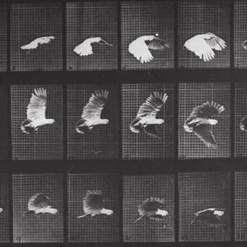
Eadweard Muybridge Animal Locomotion (1878)
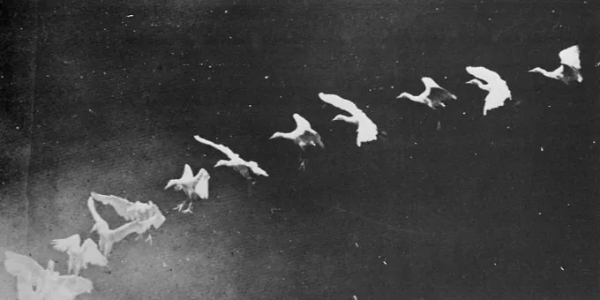Etienne-Jules Marey "The Physiological Station at Paris” Scientific American Supplement, 8 December 1883
Marey’s “Synthetic Reconstruction of the Elements of an Analyzed Movement” – one of the chapter titles from his book Movement (1894) – found its way into visual culture in profound ways, including work by the Italian Futurists and more explicitly Marcel Duchamp’s exploration of time, as opposed to space, in a Cubist idiom. Multiple works of his in 1912 pursued Marey’s lead, famously so in “Nude Descending a Staircase.” Duchamp’s kinetic cubism is a synthetic blend of chronophotography, Picasso and Braque’s spatial cubism, and Futurist sculpture as engagements with the machinic and motorized age. Muybridge and Marey, of course, lead directly to time-lapse photography of both still and moving images including cinema but most importantly animation with photographic film as its material base.
Muybridge’s insight to sync a shutter to an action in the world and freeze it in an infinitely repeatable form displays digital thought processes applied to analogue technology. Digital tech converts information into numbers and stores them in this fashion and hence has no relation at all to the thing stored, which has advantages and disadvantages. Its primary qualities are discontiguous linkage as well as the compression and storage capacities of information: the division of temporal phenomena into infinitely repeatable spatial units (e.g. Muybridge). Taking Muybridge’s opto-mechanical photographs (or “motion capture”) a step further, Marey developed his “graphic method” of graphs, diagrams and charts to study bird and animal motion as data operations: birds flying through data. Setting aside Marey’s questionable studio practice of attaching electrical cables to some of the birds he photographed, he and Muybridge helped pioneer machine-based datafication of animal and human bodies that has played substantially significant roles in the logics behind time-motion studies in Taylorist industrial production and the late 20th century “quantified self” (fit-bits, health apps, etc). This work also leads to become data-based art. Treating data as both the content and medium follows a key modernist dictum and currently of art holds significant sway in “new media” art.
The images selected here from these pioneers of chronophotography and film-based animation (as opposed to other earlier motion visualization machines such as the zoetrope) provide historical allusion, as well as data-driven analysis and replication in the ornithologically-rich animated work of William Kentridge. The artist describes the copper plates that he made for the print sequence Bird Catching: four plates, as being “records of damage…about capturing time, the time of making…” – a description that could be equally applied to 19th century chronophotography without the copper plate gouges. Marey and Muybridge clearly engaged in their own forms of catching that emerge stunningly altered, elaborated and celebrated in Kentridge’s moving image pieces of human-avian interactions and metamorphoses. We also experience in his work conversions of time into space that easily reverts into time through painstaking stop-motion animation (25 different stills for one second of action, Kentridge 41). The data is captured in film stock, charcoal animation, print plate, etc. The charcoal animations of bird flight, or even the sequences that could be storyboards for animated work, harken back to the non-film-based visual technologies of motion animation in flicker books and zoetropes as well as obviously to Marey and Muybridge. In the process, though, the charcoal animation captures vestiges, remnants, even revenants of its earlier incarnation. For Kentridge, the entire history of bird flight visual study and technologies of movement provide content, leitmotiv and media for his work.

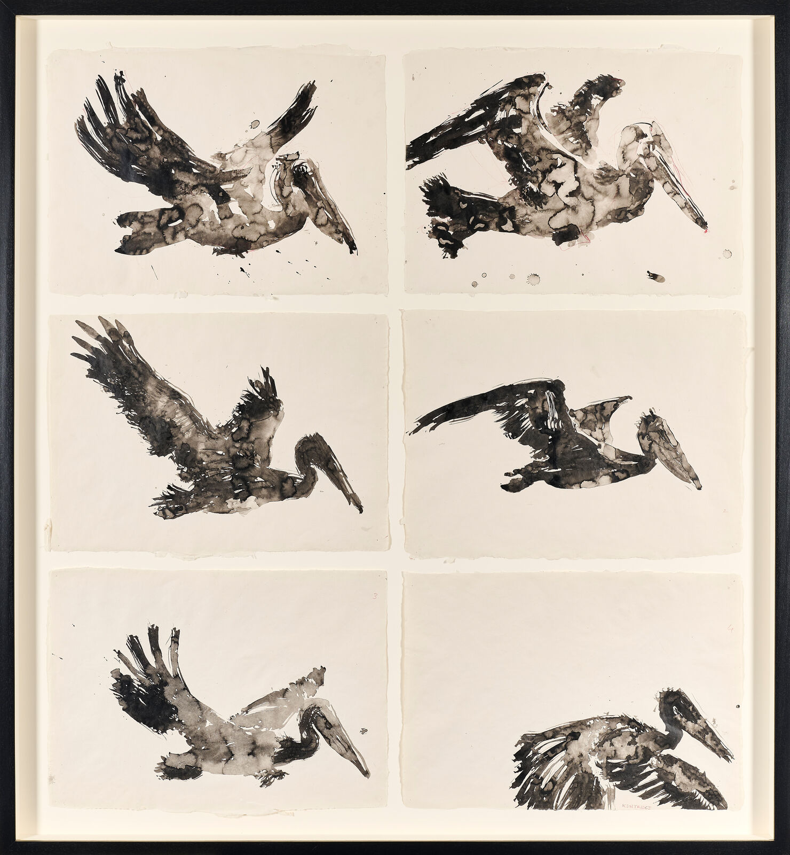
William Kentridge, drawing for “Self-Portrait as aa Coffee Pot, Pelican in Flight” (2022)

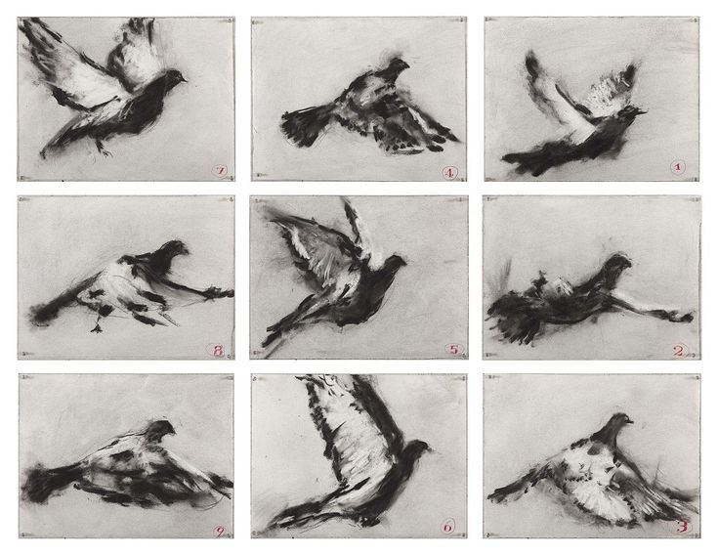
William Kentridge, Untitled, 2011
Bird Automata
The co-evolution of humans and birds, as well as the latter’s autonomous agency and actions, make birds for humans a source of wonder, curiosity, awe and fear. That birds have been substantive factors in human world-making and cosmology formulations makes them not only useful symbols for poetry, music and art but media linking humans to the ways we interpret the universe. The ontogenesis of mechanical relations between humans and other species, particularly birds, have long appeared in technological interpretations and mimicking. As the Western world shifted from an age of the gods to a more human-centric universe, the datafication at play in Marey’s chronophotography reveals a history connected to ancient automata and then the clockwork precision of 17th century mechanisms that runs through Renaissance studies of the natural world.
Pierre Belon’s “L’histoire de la nature des oyseaux” (A Natural History of Birds) from 1555 was an early example of fieldwork and examination of different species in laboratory conditions that helped inform his detailed woodcut illustrations. Drawing on Bellon’s extended travels in Greece, Palestine, Asia Minor, Egypt and Arabia, the book offers one of the first studies in comparative anatomy, and one in which the bird in the human, or vice versa, exemplified a predilection for isomorphic analogy. The human structure depicted in the comparative in the portraits below is less an exercise in the biomechanics studied by Marey than in corporeal and skeletal resonance. The juxtaposition of the skeletons presents similarities between predator and prey, read left to right, and food source and consumer, read bi-directionally, with each being the eater and the eaten. The striking woodcuts appeal to a shrouded avian ancestry resident deep in our shared upright stance. Stripped of muscle, flesh and organs (and feathers) the work of gravity on the skeletal hangings and resultant verticality exaggerate a likeness that, in turn, suggest the biotechnology and biomechanics found in Leonardo da Vinci’s inventions and notebook illustrations.
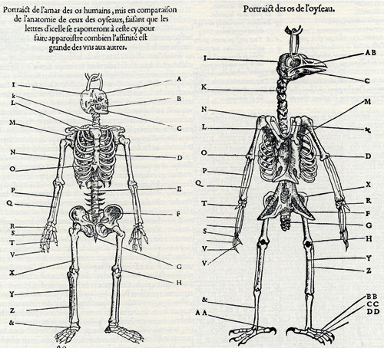
Comparison of the skeleton of bird and human. From the French author Pierre Belon’s 1555 book L'Histoire de la nature des oyseaux (Natural History of Birds).

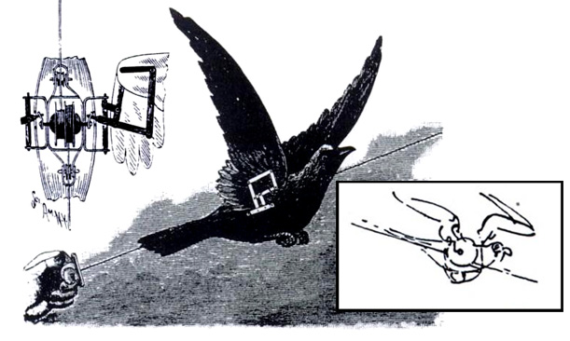
Leonardo da Vinci mechanical bird prop for theater, inset a toy later modelled on it
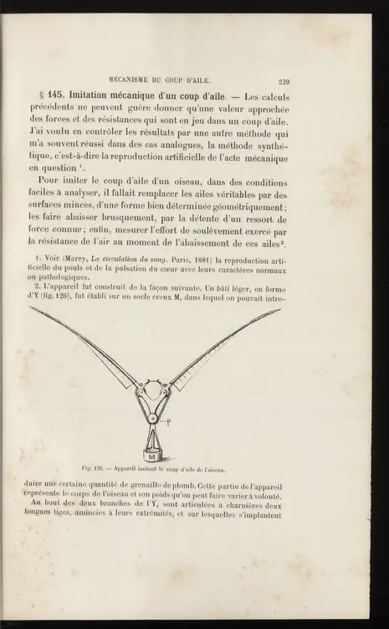
Marey’s chapter image: “mecanism le coup d'aile” from The Flight of Birds (1890) – literally “the wing-stroke mechanism”
Just as he was obsessed with complex dynamic systems such as wind and water flow, Leonardo was another polymath obsessed with flight of all kinds as his notebook illustrations of flying machines and birds exemplify. Marey’s images of the flight mechanism might have been modelled on Leonardo’s bird on a wire set of drawings. Depicted above is a bird mechanism he created to simulate flight for a stage production. This dramatic contribution, though, was a simple device composed of wings that flapped as the artificial bird descended a wire. He designed essentially the same mechanism for the wired birds that “flew” to ignite wagons filled with fireworks in the Florentine Easter festival “Scoppio del Carro” (the explosion of the cart) that he also designed. This quite literal deus ex machina provided a ballistically-charged inauguration of the Easter festivities. As with other kinds of avian divination, if the robotic bird hit its mark properly and ignited a grand explosion, then a good harvest and a stable civic society ensued for the coming year.
Leonardo bought caged birds in large numbers to set them free and observed them in flight, swooping and climbing on the invisible dynamics of air. Notebooks filled with sketches and descriptions of flight and dynamic movement allowed him to examine data on motion, impetus, force, proportional distribution of weight, and the structure of bird wings. His sketched studies sought a temporality and dynamism that belied the stillness of the image, which he understood as a tiny, scientific slice of the larger process from which it was excised for potential replication (Notebooks 83-105). Similar dynamic systems studied in the notebooks include wind proxies, water flow and cloud transformations.
His work carried forward ancient studies in mechanics for the creation of automata, famously of birds and bird songs, and provided data and measurements for physiology, anatomy, physics and the future flourishing of automata in 17th century Europe. Giovanni Alfonso Borelli’s De motu animalism arrived two centuries after Leonardo and expanded these biomechanics by explicitly exploring geometrical relations between animal movement and human anatomy. The special reliance on bird analyses was integrated into the increased complexity of automata and robotic mechanisms. In this manner the work in Europe became accessible to expanding aristocratic and bourgeois classes while that mirrored such technological diversions in Islamic courts.
Ancient automata that fused sophisticated pneumatic systems of mechanics in the simulation of movement and sound to delight the court and entertain dignitaries also added to the store of cosmological insights and interpretive practices, going back millennia. Archytas of Tarentum, now modern Puglia, was one of the last great thinkers, mathematicians and politicians of the early Pythagorean tradition. In addition to assembling the first volume of knowledge divided into four mathematical arts (astronomy, logics, music and geometry), Archytas was, according to Diogenes Laertius, “the first to systematize mechanics by using mathematical first principles” and is thus accredited by many as the founder of automata. But as with many claims that emerge from the pre-Socratic world, there are challenges to this idea. The evidence that he created a wooden dove automaton have been countered with his work on war machines and that perhaps the dove was just a catapult projectile as part of his ballistics research. One certainty remains: birds have long inspired what we might call the early history of biotechnology through the mechanical imitation of avian movement and song.

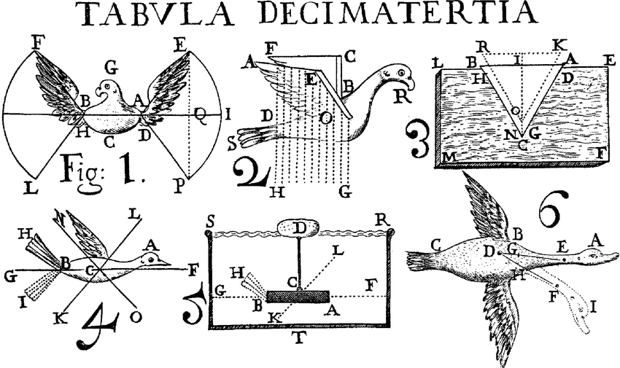
Giovanni Alfonso Borelli De motu animalium (1734)
Animal motion, and bird flight especially, contributed to multiple branches of scientific inquiry into the data collection of biomechanics relevant to human skeletal studies of motility and the bird resident in our bipedal upright stature. This data translated to mimetic works of animal and human motion in automata throughout the ancient world and reaching an apex of sorts with European clockwork technicians before being reconfigured and further animated by Muybridge, Marey and the many streams of visual technology that merged into a river of cinematic technology.
Two clock mechanisms nestle inside of Marey’s photographic gun, one driving the motion of the plate and image-capture system while the other automatically altered multiple aperture settings. Not only did this potentially allow Marey to catch the mechanics of bird flight but it echoed the material power of the mechanistic universe then waning into a random one awash with probabilities, actuarial tables, risk and potential human control absent in a clockwork cosmos.
W.B. Yeats’ famous invocation in “Sailing to Byzantium” of gold craftsmen providing “monuments of unageing intellect” in the form of metallic birds untouched by mortality placed on “a golden bough” to “sing … of what is past, or passing, or to come.” The nod to James Fraser and the formulation of timeless monomyths of ancient wisdom held as much appeal for high Modernism as it did for the late 19th century. This fascination appears in mechanical contrivances across centuries. They populate ancient texts and can be found modern recreations of the past’s clockwork glories. The simulated movement, sound and the controlled beauty of systematic processes captured the natural world in technological delights.
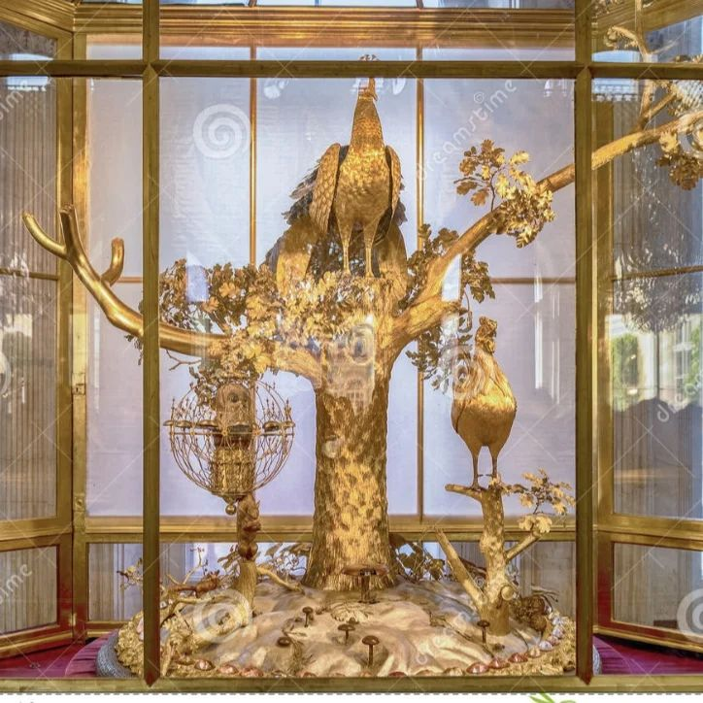
James Cox’s 18 century imaginary remake of the Byzantine throne was a gift to Catherine the Great and now resides at the Hermitage in St. Petersburg.
Possibly taking inspiration from Cox’s reimagined Byzantine glory, Yeats’ famous lines appear rendered in three-dimensional goldwork.
“Once out of nature I shall never take
My bodily form from any natural thing,
But such a form as Grecian goldsmiths make
Of hammered gold and gold enamelling
To keep a drowsy Emperor awake;
Or set upon a golden bough to sing”
(W. B. Yeats, 1927)
Yeats studied ancient texts, diagrams and descriptions that, in turn, provided context for the poem’s neo-Platonic yearnings. These materials became catalysts for his Giambetissto Vico-inflected formulations of historical cycles. Works such as the one found in Liutprand of Cremona's Antapodosis 6.5, dating from the first millennium A.D. also helped fuel Yeats’ fanciful historical reconstruction:
“In front of the emperor’s throne there stood a certain tree of gilt bronze, whose branches, similarly gilt bronze, were filled with birds of different sizes, which emitted the songs of the different birds corresponding to their species. The throne of the emperor was built with skill in such a way that at one instant it was low, then higher, and quickly it appeared most lofty; and lions of immense size (though it was unclear if they were of wood or brass, they certainly were coated with gold) seemed to guard him, and, striking the ground with their tails, they emitted a roar with mouths open and tongues flickering.” (Trans. Paolo Squatriti)
https://archive.org/details/brett-1954-byzantine-automata/page/481/mode/2up

The concerted study, analysis and interpretation of animal movement that finds its way into automata simulations and imitations takes wing for Renaissance Europe from tomes rediscovered, translated and read anew after the fall of the libraries of Toledo (1083) and Cordoba (1236). The trickle of translations over the Pyrenees into France and beyond merged lost tomes from Carthage and other massive libraries combined with the Arab philosophical-scientific tradition. One of the latter included a particularly tantalizing text of ancient automata is The Book of Knowledge of Ingenious Mechanical Devices, by Ismail al-Jazari, dating from 1206. Al-Jazari was also called “the father of robotics” and his influential Arabic text appeared a few centuries after Litprand of Cremona published his. The technological exchange of physics and mechanics between the North and South (or East and West) during these centuries somewhat too easily mirrors the migratory patterns of the feathered collaborators of this knowledge production and application.

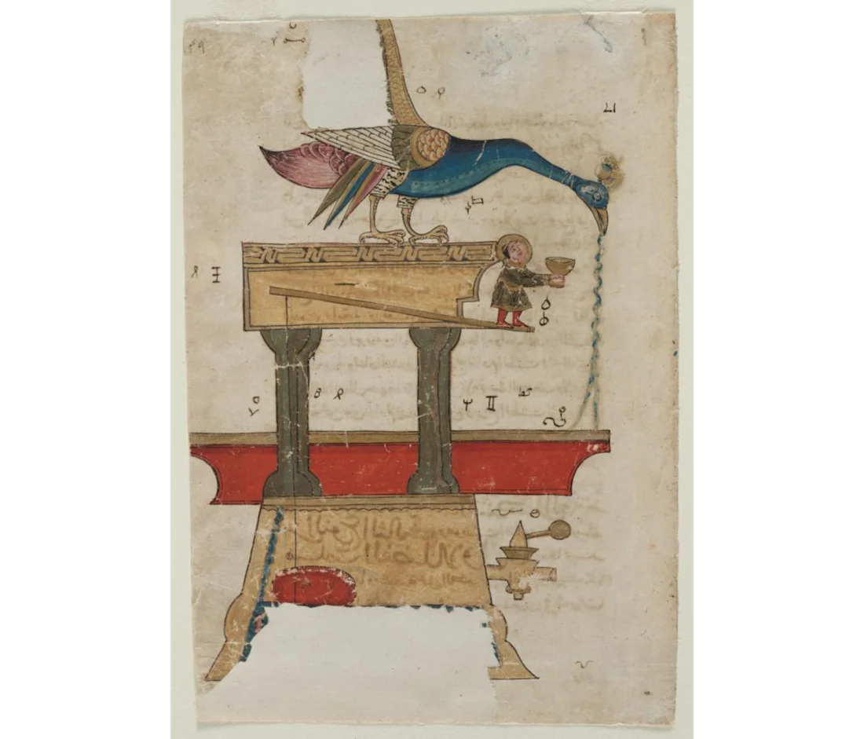
Image from The Book of Knowledge of Ingenious Mechanical Devices, by Ismail al-Jazari

The earliest interests in bird automata recognized the importance of intelligence and knowledge existing in the world beyond humans. This intelligence existed beyond a single entity, especially a human one, bounded by its corporeal frame proved even more productive. From the very outset, a recognition that informational exchange occurred within complex, multi-membered systems existed and thus increased study of collective activity, movement and decision-making ensued. Non-human collective intelligence was evident everywhere in nature from insects to fish to birds. The (mostly) post-WWII Macy conferences that gave rise to cybernetics and information theory, complex systems theory linked human and animal intelligence with each other as well as machines. This is baldly stated in the title of Norbert Wiener’s immensely influential Cybernetics: Or the Control and Communication in the Animal and the Machine from 1948. From that point on, robotic animal life sprang up everywhere as lab-created creatures of systemic complexity and mechanics proliferated. Examples include Wiener’s light-sensing robot moths, William Grey Walter’s electromechanical turtles, von Neumann’s self-replicating automata, and Claude Shannon’s mechanical rat that conquered mazes. Shannon’s wide-ranging interests included a sustained focus on ant and bee communication (John Johnston p. 1 Parikka p. 123) that signaled a step toward animal intelligence and human interpretation beyond mere imitation into the realm of interpreting collective behavior and movement as keys to understanding the nature of intelligence and information. They also unlocked imaginaries and plans to manipulate and leverage this knowledge for human gain of various kinds: financial, military, environmental, and epistemological.
ICARUS: Mapping Avian Migration and Human Futures
“What if we started tracking animals from the International Space Station?” –Bill Cochran, early innovator in wildlife telemetry
Project Icarus operates out of the Max Planck Institute in Berlin and is dedicated to studying animal migratory routes and conditions for their existence. Gil-Fournier and Parikka briefly discuss Project Icarus although it was dormant at their time of writing – a casualty of German state funding cuts immediately after the Russian invasion of Ukraine. The project resumed operations in 2025. ICARUS stands for International Cooperation for Animal Research Using Space. In addition to generating detailed information about migration routes and herd or flock health and infectious diseases, the project collects epiphenomena “that should even help to predict ecological changes and natural disasters” ( https://www.icarus.mpg.de/en). ICARUS is a kind of digital ornithomancy that brings datafication into the realm of divining a collective future for all the earth’s species. If the computational models derived from 10.6 billion sensor locations, 8.9 million other sensor records, thousands of scientific studies birthed by the project, nearly 2,000 taxa and almost 6,000 data owners converge with some collective accuracy, we might be able to predict and alter significant climate patterns, Invoking the myth of Icarus as the tragic human copy of bird flight to indicate potential futures for life on the planet makes the project’s moniker properly dire while predicated fully on collaborative hope. Movebank, part of Project Icarus, provides an open-source online data base that helps “animal tracking researchers manage, share, protect, analyze and archive their data” for use by students, journalists, other researchers and interested parties. As such, it offers an open-source version of collective intelligence and collaboration. (https://www.movebank.org/cms/movebank-main)
Vladen Joler, Gordan Savičić and Felix Stadler’s 2022 data-driven artwork “Infrastructure of a Migratory Bird” is a navigable diagram/map that scales from insect to planetary levels. The artists focus on the bald ibis to examine species rewilding in geographies from which it has mostly disappeared. The Northern Bald Ibis, a large migratory bird, was reintroduced into its African, Middle Eastern and European habitats after being locally extinct for over four centuries. In an age of comprehensive datafication, they state that the bald ibis species “does not only fly through the air but also through data” -- as did Marey’s subjects. Their diagram “shows relationships between social, technological, informational and ecological elements which make up the anthropogenic ecosystem in which the bird is becoming wild again.” The scales also, however, offer different interpretative angles one can investigate with the assembled, filtered and diagrammed data, including “spatial, monetary, and temporal dimensions.” Potentially discernible in the various elements of the pictorial tool are multiple causes of, solutions to, and unintended consequences of species extinction and rewilding projects. This critical mapping practice assembles complicated causal relationships between the artificially separated domains of human infrastructure and the environment to visualize “the intricate network of data, energy resources, and dependencies enmeshed” with which such an artistic ecological project can contend.
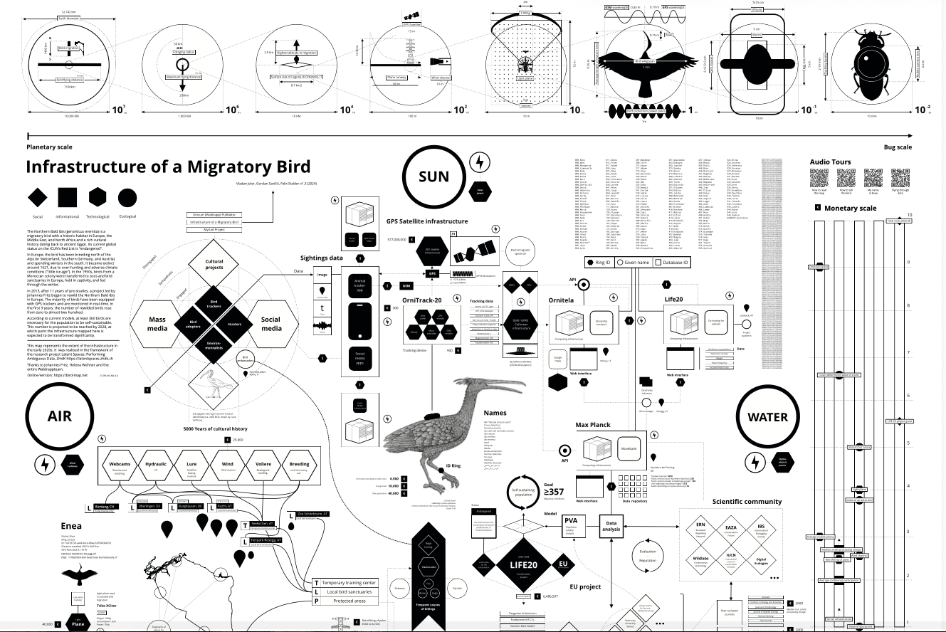
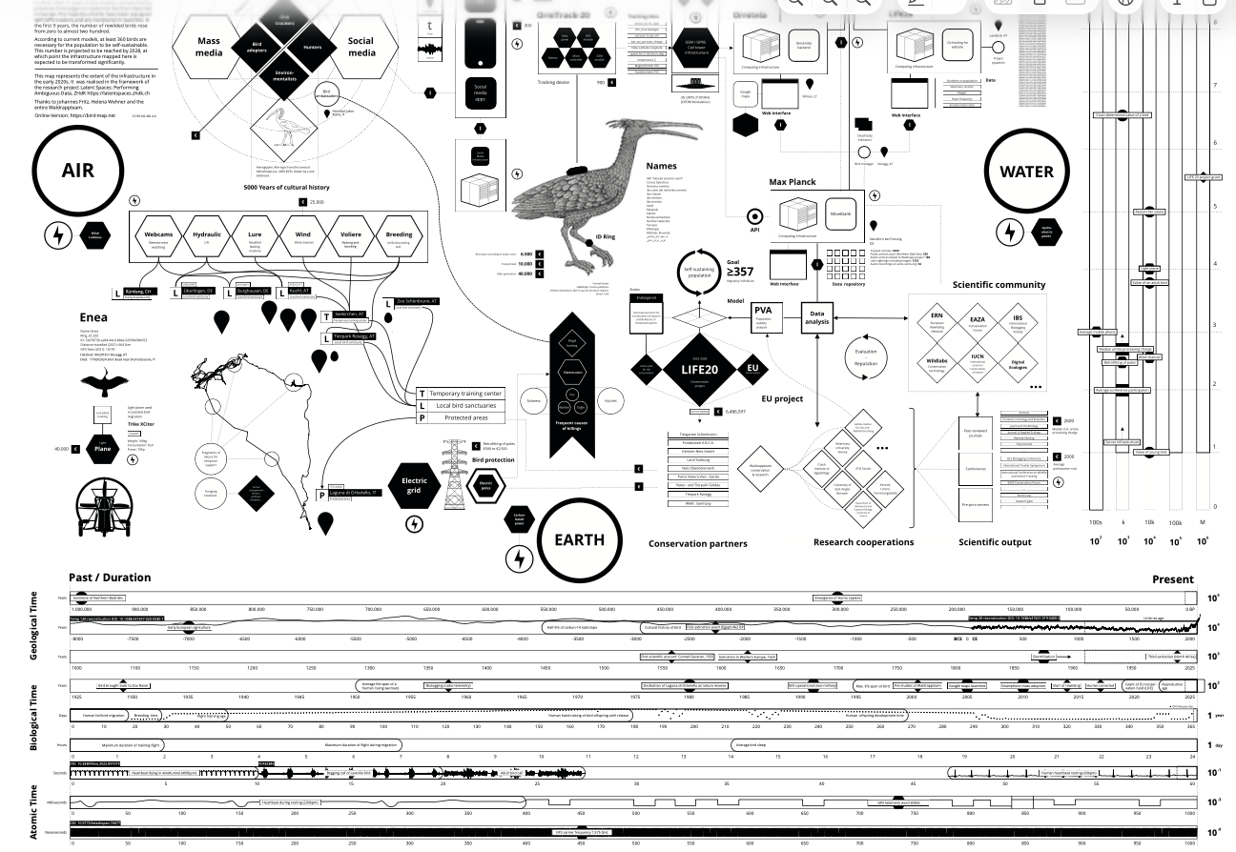
Vladen Joler, Gordan Savičić and Felix Stadler “Infrastructure of a Migratory Bird” (2022 https://latentspaces.zhdk.ch/imb/)
Models, Murmuration and Swarms
“Swarming is seemingly amorphous, but it is a deliberately structured, coordinated,
strategic way to strike from all directions, by means of a sustainable pulsing of force
and/or fire, close-in as well as from stand-off positions. It will work best—perhaps it will
only work—if it is designed mainly around the deployment of myriad, small, dispersed,
networked maneuver units…This study derives insights from examples of swarming in nature and in history.” – John Arquilla and David Ronfeldt Swarming & The Future of Conflict

For a 2019 exhibition Jussi Parikka and I curated entitled “Earth/Sky,” the Egyptian-German artist Heba Y. Amin contributed a moving image work comprised of found drone footage of migrating birds. “As Birds Flying” combines politics, paranoia, environmental tracking and surveillance. Amin’s artwork was inspired by a 2013 incident in which Egyptian officials, worried about Syrian conflict surveillance, captured a stork fitted with an electronic tracking device used for migratory data gathering and not an aerial spying apparatus. The absurd conspiracy resultant from the tagged birds foreshadows Defense Advanced Research Project’s (DARPA) hummingbird surveillance drone developed by AeroVironment – the Nano Hummingbird Drone. Unveiled to the public in 2011, this tiny reconnaissance drone could only be in the air for 11 minutes, a far cry from contemporary long-range drones and thus limiting its spying appeal. Similarly, hummingbird design allows for rapid darting about spaces but without much straight-line speed. Yet another specific drawback for covert surveillance would be the inability to deploy it in geographical areas where this species does not exit.
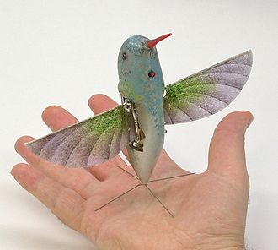

That said, the lull in their appeal and feasibility between there earliest rollout in 2011 has once again picked up momentum with multiple researchers at various university and corporate labs funded by the US Department of Defense turning increasingly to hummingbird flight for a vibrant strand of futural drone technology. Central to the development of zootechnics for military strategy and theory as found in swarm theory comes from innovations in computer animation in the last decades of the 20th century.
Boid algorithms, developed by Craig Reynolds in the late 1980s for bird flocking and murmuration simulation, are based on three determinative elements: separation, cohesion, integration. This provides an elegant modeling tool of emergent complexity, when simple systems or groupings become complex. Reynolds paper “Flocks, Herds and Schools: A Distributed Behavioral Model” (SGGRAPH 1987) proved hugely influential for computer modelling and animation graphics. Building on the work by 19th and early 20th century physics to understand and predict dynamic systems, the complex systems theory models exemplified in these simulations not only found form in computer animation but influenced autonomous vehicle research, military R and D research on swarming robotics and modelling for social network systems.
Synchronized group behavior such as murmuration proved both particularly challenging for modelling software and particularly productive because the individual members of the murmuration flock respond to multiple members within seven milliseconds to nearby birds across topological distances. Separation, cohesion and integration as well as stochastic noise in capacities of prediction -- hence complexly generative collective movements -- became the basis for simulation and animation. Focusing on the aerodynamics of individual bird movement entailed interaction with others in the flock and vice versa: the many as the one. This is a form of “particle systems” modelling used to animate “fuzzy objects” in dynamic operations such as fire, smoke, and oceanic spray in the 1980s (Reynolds 26). Reynolds Boid algorithmic model presented “polarized, noncolliding, aggregate motion” (33) that partially relied on a simulated perception of the individual flock members. It also relies on a simulated perception of humans observing this distributed mind in action.
Murmuration modelling contributed to a larger understanding of swarming behavior by insects and animals. Sebastian Vehlken writing on this aspect of zootechnologies states that “swarms shimmer in a field of tension between interference and organization whose discursive and historical dynamics are resistant to any subject-oriented or analytical perspective” (2019: 30). Da Vinci had a taxonomic category called “bodies without surfaces” -- a visible body without clear boundaries or defined shape, including mud, water, smoke, mist, clouds and swarms. These were distinguishable from another kind of visible body determined by its shape and form. (Vehlken 35 -- Da Vinci, Codex Atlanticus, 132rb). The mysterious, evanescent yet discernible body without form held special appeal for Da Vinci as that which could not take shape or find form. His extended studies of the various examples of them, and his sketches that freeze constant movement into a solitary moment of mutation evidence this sustained interest.
A visible body without a surface also holds useful military applications. Swarm modelling, provided by Reynolds and others, informed an area of military R and D strategy known as “swarm theory.” Which was codified in a paper by John Arquilla and David Ronfeldt in 1997 entitled “Swarming and the Future of Conflict”. Produced for the RAND corporation, the paper proved prescient. Their datafication and prediction theories about the strategic military advantages of swarm and flock weaponry can be seen in the current asymmetrical drone warfare being conducted in the Ukraine and Iran warzones. Characterized in the popular press as “the birds and the bees,” swarm theory primarily relied on bees and bee swarming for their future-war planning but also leveraged murmuration patterns of birds and other animal swarm intelligence in military planning and prediction. Swarm theory deploys the flexibility and chaos of decentralized systems, much like the internet, and that is their appeal. Such planning currently allows Ukraine and Iran to cripple the lumbering military behemoths of Russia and the US in ways Arquilla and Ronfeldt predicted three decades ago.
The opening lines of their report, quoted in the section epigraph, set the stage for a massive military strategy redesign found resistance in the US military for several decades. During the same decades, swarm technology and hardware research inexorably continued, nonetheless. Swarms result in confusion and turmoil for human perception, unable to follow micromovements of multiple bodies joined formlessly into one. They are perfect for generating the fog of war for the enemy. The ramifications of this theory and its biomechanical, zootechnological foundations are currently redrawing the geopolitical map as swarm “bodies without surfaces” populated by inexpensive drones menace the hyper-advanced and ruinously expensive military machines of global superpowers. The potlatch waste of personnel and material witnessed in Ukraine and Iran are updated versions of the asymmetric strategies of the Vietcong in the 1970s. Arquilla and Ronfeldt understood the potential for a biomechanical, zootechnological future warfare strategy that constitutes our present, their lessons primarily learned by those fighting from disadvantageous positions in asymmetrical warfare.
So we know what the world is fighting for, we can turn to the biomechanical transformational possibilities afforded by technologically mimicking bird flight for the future of congested urban travel infrastructure: new flying cars for executives. The South African based company Phractyl has designed a zootechnological wonder to work overcome urban infrastructural inadequacies that lead to horrendous traffic jams in overcrowded cities throughout the African continent and elsewhere. Called the Macrobat, the whirring, tilting bipedal helicopter/airplane can allow busy executives to circumvent pesky traffic through the parabolic arc of bird flight. Its bird-inspired limbs allow for “near vertical” liftoff and landing, according to the company’s advertising.
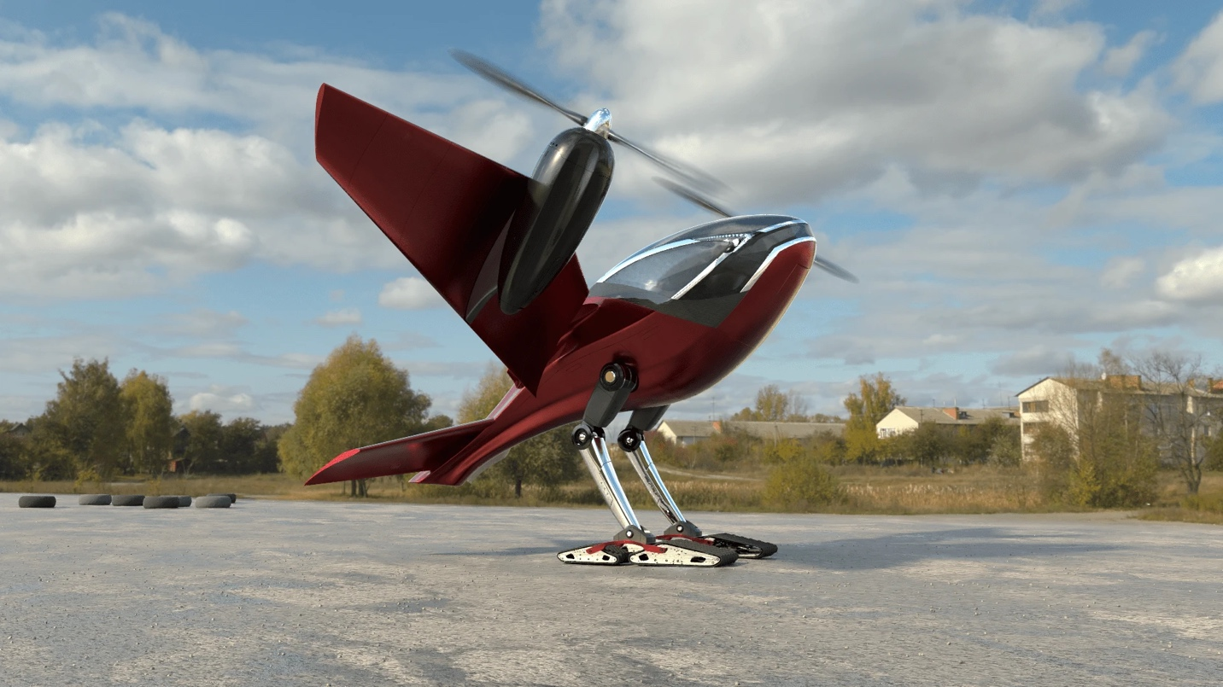

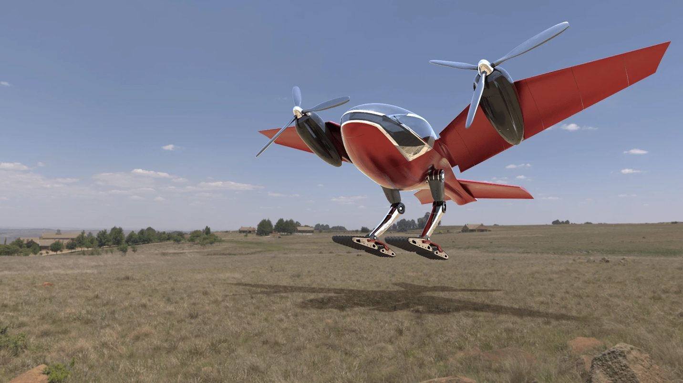
https://newatlas.com/aircraft/phractyl-macrobat-nvtol-africa/
The single-seat personal helicopter was featured in the 14 December 2021 issue of the lifestyle magazine LuxuryLaunches. This article focuses on the borrowed bird bits to tout its liftoff and landing capabilities that also allow the vehicle to imitate avian tail mechanics to escape rough terrain hostile to standard helicopters. Phractyl claims the Macrobat is “the world’s first near-vertical takeoff and landing (NVTOL) aircraft.” (https://luxurylaunches.com/transport/this-unique-bird-like-flying-car-from-africa-has-tracked-feet-and-can-take-off-and-land-from-any-terrain.php) These images above are digital renderings of the vehicle in development for both piloted and autonomous flight.
The company’s website describes its mission and epistemological drive by explaining its moniker as “The PHRontier for Agile Complex Technology sYstem evolution” – what the company calls a “hackronym” or near but not quite acronym. The name intends to invoke dynamic solutions thinking approaches to problem-solving (https://phractyl.com/). The surreally fun design and Joycean linguistic play clearly indicates that their remedy to gravity is levity, even if for the super-rich.
Conclusion: Avian Hermeneutics
The skeletal comparative sketches in Belon’s 16th century natural history of birds maps neatly onto the cyborg vision of future luxury commuter travel above. The trajectories from Hittite divination to Archytas of Tarentum to Ismail al-Jazari to Da Vinci/Borelli and Belon and on to Marey and Kentridge, followed by Arquilla and Ronfeldt to the Macrobat renders a repetition of animal motion techno-poetic shaping of avian-fuelled interpretation and inspiration. This paper offers an incredibly simple take on a complex entangled relationship between human digital and analogue technologies, and imaginations and interpretations of zoological movement. The two inextricably intertwined developments of datafication and/as divination continue to enthrall. If the aubade at the dawn of this paper is perhaps our earliest example in the very long history of avian hermeneutics going awry, we do have some telling examples of datafication and augury that align with our interpretations of them. The Project Icarus strand, including Movebank and Joler et.al.’s migratory infrastructure diagram, provides readings of bird species as being literally canaries in the coalmine of our collective ecological future that seems unfortunately and horrifyingly accurate.

